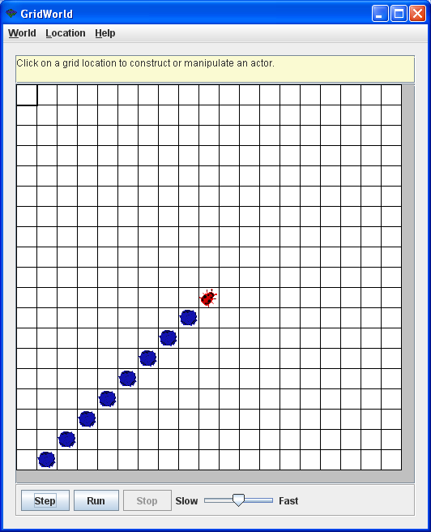

# Use a sentinel value pattern

Get the location behind the bug

While (that location is in the grid) {

Add a Rock at that location

Get the next location behind that location

}